NAME:________________________ DATE:__________________

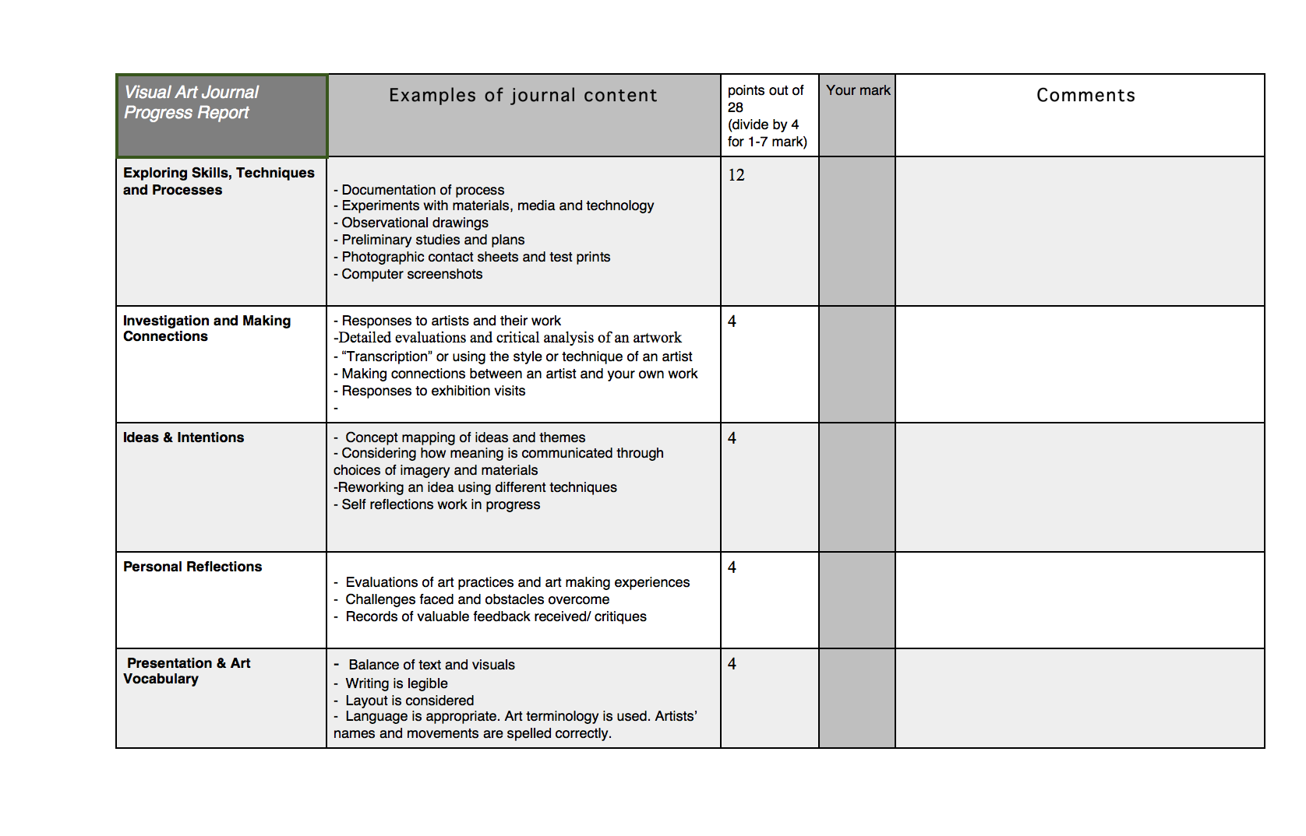

NAME:________________________ DATE:__________________